Appendix 4
High School Three-Year Model:
Every Science, Every Year

2016 Science Framework for California Public Schools
Kindergarten through Grade 12

The CA Science Framework was adopted by the California State Board of Education on November 3, 2016.
The CA Science Framework has not been edited for publication. © by the California Department of Education.

Appendix 4:
High School Three-Year Model: Every Science, Every Year

Comparison of High School Science Sequence Models
The Science Framework for California Public Schools: Kindergarten Through Grade Twelve (CA Science Framework) presents three alternative curricular sequences for implementing instruction to meet the Science Standards for California Public Schools, Grades Kindergarten Through Grade Twelve (CA NGSS). The Four Course Model presents disciplinary core ideas (DCIs) in four discipline-specific courses: biology, chemistry, physics and Earth & space science (ESS). The Three-Course Model integrates all Earth and space science DCIs into biology, chemistry, and physics courses. In contrast with both of these models, the Three-Year Model called “Every Science, Every Year” presents all of the major subdisciplines of science in a developmental progression that unfolds during three successive courses. The purpose of this model is to use DCIs, science and engineering practices (SEPs), and crosscutting concepts (CCCs) to coordinate and blend biology, chemistry, physics and geoscience into a unified science curriculum that promotes the development and application of reasoning skills and concepts within, between, and beyond traditional curricular boundaries, in order to promote the development of transferable reasoning skills that can be used throughout life.
This model is designed to help students learn to apply the CCCs across traditional disciplinary lines to make sense of new learning. Although all models emphasize the use of CCCs, the Three-Year Model employs CCCs as the organizing principle.

Pedagogically-Sound Learning Progression
When developing a curricular sequence for an integrated science course, educators should consider arrangements that facilitate three-dimensional learning, maximizing the use of SEPs and the application of CCCs to learn new DCIs. Knowledge and skills should build within a course and between courses. The executive summary of the Next Generation Science Standards (NGSS) states that “The emphasis of the NGSS is a focused and coherent progression of knowledge from grade band to grade band, allowing for a dynamic process of building knowledge throughout a student’s entire K–12 scientific education” (NGSS Lead States 2013a). The Three-Year Model: Every Science, Every Year strives to achieve this goal.
The sequence suggested in this outline is designed so that fundamental and transferable concepts are taught earlier in the sequence so that students can use them to learn more complex and specific concepts later in the sequence. “Fundamental concepts” are those that are necessary for understanding more specialized concepts, whereas “transferable concepts” are those that have wide-applicability and can be used to unify learning across traditional disciplinary lines. When examining the curricular overview (figure App 4.1), one will notice that DCIs are arranged from top to bottom and from left to right. The concepts in the upper left of a course are more fundamental and transferable than the concepts in the lower right. For example, in course 1 (figure App 4.2), the physical science concepts of forces and motion are introduced first because they can be used to understand concepts such as the structure and function in animals (e.g. muscle action, body levers, kinesiology), and the forces moving tectonic plates and eroding the physical landscape. In addition, more basic concepts are introduced in course 1 so that they can be applied in course 2 (figure App 4.3), and less-basic concepts are introduced in course 2 so that they can be applied in course 3 (figure App 4.4). For example, forces are introduced in course 1 as pushes and pulls, so that one can understand what energy accomplishes through the four fundamental forces when energy is introduced in course 2. Similarly, the structure [CCC-6] of the atom is introduced in course 1 so that students are prepared to understand the chemistry of biogeology in course 2 as well as nuclear reaction in course 3. The structure of the atom is a more fundamental concept that can be used to explain the later two concepts, while neither nuclear reactions nor biogeology can be used as well to introduce students to the structure of the atom.

Learning from Other Successful Countries
Integrated science models have a strong track record of success in other countries and provinces. Analyzing the science standards of ten countries that produce significant scientific innovations and score highly on international benchmark tests, Achieve (2010) found that all ten of these countries use an integrated science model through middle school, and seven of the ten countries keep science integrated all the way through Grade ten. Summarizing qualitative trends from their analysis, Achieve (2010) concluded that, "Standards based around 'unifying ideas' for Primary through Lower Secondary seem to confer more benefits than a discipline-based structure." This statement articulates part of the rationale behind the seven crosscutting concepts from CA NGSS that link together all disciplines of science and engineering. Given that these CCCs cannot be comprehended within a single context or even a single scientific discipline, this Three Year Model is designed around progressions in CCCs.

Three-Dimensional Learning
The NGSS are designed to encourage “three-dimensional learning,” symbolized by the logo shown in figure App 4.1. The three dimensions are disciplinary core ideas (DCIs), science and engineering practices (SEPs), and crosscutting concepts (CCCs). Students employ SEPs to learn DCIs. In the process, they apply CCCs across traditional disciplinary boundaries. The CA NGSS performance expectations (PEs) provide a framework for assessing this three-dimensional learning.

Figure App 4.1: The Three Dimensions of NGSS are Intertwined.
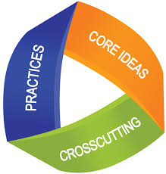
Source: NGSS Lead States 2013b

Three-dimensional learning requires students to think like scientists and engineers. They must employ SEPs to solve problems and understand concepts. Rather than memorizing the discoveries and inventions of others, three-dimensional learning requires students to ask questions that will lead to personal discoveries to explain phenomena, and define problems that can be solved using simple engineering principles. Rather than simply memorizing the models developed by scientists and engineers, three-dimensional learning requires that students develop their own models [SEP-2] to represent how the world works. Rather than simply studying the investigations [SEP-3] of famous researchers, three-dimensional learning requires that students plan and conduct investigations, analyze and interpret the data, and use mathematics and computational thinking to describe what they find. Finally, three-dimensional learning requires students to construct explanations and design solutions [SEP-6], to defend such explanations and designs using evidence [SEP-7], and to evaluate and communicate [SEP-8] their ideas to others.
For students to think like engineers and scientists, they need to apply CCCs between multiple disciplines or topics. For example, students who are trained to see patterns in the distribution of earthquakes and volcanoes will be better able to recognize patterns in species distribution within an ecosystem. Students who think like scientists and engineers realize that patterns [CCC-1] in data suggest underlying causes [CCC-2]. Earthquakes and volcanoes are not randomly distributed around the world, but appear in specific groupings that suggest common underlying causes. Similarly, organisms are not randomly distributed in an ecosystem, but are found in distributions determined by underlying causes such as microclimate and soil type. Using three-dimensional learning, students apply the principle of cause and effect [CCC-2] to a wide variety of phenomena, regardless of traditional disciplinary classifications. Three-dimensional learners understand that concepts such as scale, proportion, and quantity [CCC-3] are helpful for understanding disciplinary core ideas in biology, chemistry, physics, and Earth and space science. They learn that such concepts as energy [CCC-5], structure and function [CCC-6], and stability and change [CCC-7] can be used in all science disciplines, thereby leveraging their knowledge to simplify the learning of new material.

The Three-Year Model and Crosscutting Concepts
Biology studies living systems, physics studies the nature and properties of matter and energy, chemistry studies the ways in which matter interacts, combines, and changes, and Earth science integrates all the sciences to understand the history of the Earth and how humans interact with it. Although these sound like distinct fields of study, there is much overlap as seen in the names of other disciplines such as biophysics, biochemistry, and physical chemistry. Although the Four Course and Three Course Models chose to organize learning according to these traditional curricular divisions, the Three-Year Model: Every Science, Every Year, recognizes these logical groupings of DCIs but relies more heavily on CCCs as an organizing principle. For example, in a traditional curricular sequence, students will learn the concept of energy and its applications in the context of one of the four major scientific disciplines. In biology, they will discuss the flow of energy [CCC-5] through organisms and ecosystems, while in chemistry they will study reactions that give off energy (exothermic) or consume energy (endothermic) from their environment. In space science they may discuss energy production in stars, while in physics they define energy as the capacity to do work. Although students are introduced to the same concept four times over, they may not fully realize that energy is energy, regardless of the discipline being studied.
The Three-Year Model: Every Science, Every Year highlights CCCs by discussing applications of such concepts in all four basic sciences within the same course. For example, in a traditional, discipline specific Earth and space science course, a student may study weather and climate as an isolated topic, but in the Three-Year Model: Every Science, Every Year, the student would be learning about weather and climate in the same course as some basic physics, chemistry and biology concepts. Figure App 4.2 illustrates a few of the many linkages between sciences. For instance, a student may learn that the energy of a hurricane can be expressed either as the total amount of energy released by the condensation of water droplets, or by the amount of kinetic energy generated to maintain the strong swirling winds. He or she will already be familiar with the concept of energy, having learned about it earlier in the course when it was introduced in a physics instructional segment. The student will know that energy is the capacity to do work and that work is the product of force and distance and will therefore better grasp how hurricanes generate strong winds. Later in the semester, the student will learn how hurricanes help cycle energy and matter in ecosystems and how they may exert a selective pressure on plant and animal species in regions where they are common. Regardless of the curricular sequence one uses, the teacher should strive to help students develop three-dimensional learning by introducing activities that require students to use science and engineering practices while applying crosscutting concepts to meet the demands of the PE.

Integrated Courses Rooted in Phenomena
A successful integrated course addresses key scientific problems and investigates them using all of the relevant branches of science. There are endless phenomena upon which one could base an instructional segment of instruction or an entire course to meet all the PEs of the CA NGSS. The scientific problem or topic of inquiry should be chosen based on the local context, including the school’s location and teacher and student interests. In Sacramento, a course might be based on processes related to rivers. In Fresno, agriculture could be the theme. Schools near the San Andreas Fault system might choose earthquakes. Coastal communities could investigate sea level rise due to climate change. A school with a championship baseball team might plan an instructional segment on the physics and biochemistry of playing baseball (they might even be able to integrate Earth science and the urban heat island effects in the stands versus on the grass playing field). Table App 4.1 illustrates a few possible phenomena. Because of the importance of local context, the Three Year Model: Every Science, Every Year is not described with the same level of detail as the other course models.
As districts, schools, or classrooms target specific phenomena, they can address the PEs in any order they wish. The course sequences illustrated in this chapter are simply one example of a developmental approach. Neither this CA Science Framework nor the State Board of Education mandates that PEs be taught in any particular year or any particular course – this decision is entirely in local control. Schools must ensure that every student can meet every PE, but they have flexibility to do this however they choose.
One challenge with building a course around phenomena is that they do not always lend themselves to a sequence that builds developmentally (i.e., the central process might include simple ideas in physical science but very complex ideas from life science). Care should be taken to select a progression of scientific problems that build upon one another. Table App 4.1 shows examples of how DCIs in multiple disciplines are required to gain a full understanding of many phenomena. Information in parentheses next to each DCI is a brief summary of how the DCI applies to the phenomena (where appropriate or not obvious).

Table App 4.1. DCI Examples in Multiple Disciplines to Understand Phenomena
 | DCIs
Phenomena | PS | LS | ESS
Landslides | PS1.B Chemical Reactions (chemical weathering)  PS2.A Forces and Motion (balanced forces becoming unbalanced)  PS2.B Types of Interactions (gravity)  PS3.D Energy and Chemical Processes in Everyday Life | LS1.A Structure and Function (roots)  LS2.C Ecosystem Dynamics, Functioning, and Resilience (succession following landslides) | ESS2.A Earth Materials and Systems (strength of materials)  ESS2.C The Roles of Water in Earth’s Surface Processes (pore pressure)  ESS3.B Natural Hazards  ESS3.C Human Impacts on Earth Systems (alterations of slopes)
Baseball | PS1.A Structure and Properties of matter (food)  PS1.B Chemical Reactions (chemical reactions for player's food)  PS2.A Forces and Motion (momentum transfer bat-to-ball, friction of sliding)  PS2.B Types of Interactions (gravity on ball in flight)  PS3.A Definitions of Energy (kinetic energy of ball)  PS3.B Conservation of Energy and Energy Transfer (energy transfer bat-to-ball)  PS3.D Energy and Chemical Processes in Everyday Life | LS1.A Structure and Function (body size versus batting average)  LS1.B Growth and Development of Organisms (Muscular system and respiratory system)  LS1.C Organization for Matter and Energy Flow in Organisms (energy from food, respiration)  LS1.D Information Processing (keep your eye on the ball)  LS2.B Cycles of Matter and Energy Transfer in Ecosystems (respiration)  LS3.B Variation of Traits (body size versus batting average)  LS4.D Biodiversity and Humans (seagulls circle overhead to eat trash) | (All three of these connections are slightly contrived)  ESS3.B Natural Hazards (Stadium safety, 1989 World Series interrupted by an earthquake!)  ESS2.C The Roles of Water in Earth’s Surface Processes (urban heat island effects -- evaporative cooling)  ESS2.D Weather and Climate (Urban heat island effects -- sitting in the stands versus being on the field)
Photosynthesis | PS1.A Structure and Properties of matter (elements and atoms)  PS1.B Chemical Reactions (how photosynthesis works)  PS3.A Definitions of Energy  PS3.B Conservation of Energy and Energy Transfer (tracking energy through photosynthesis)  PS3.D Energy and Chemical Processes in Everyday Life  PS4.B Electromagnetic Radiation (energy source) | LS1.A Structure and Function (cells, leaves)  LS1.B Growth and Development of Organisms (DNA fabrication of chlorophyll)  LS1.C Organization for Matter and Energy Flow in Organisms (food webs, carbon cycle)  LS2.A Interdependent Relationships in Ecosystems (food webs)  LS2.B Cycles of Matter and Energy Transfer in Ecosystems (respiration)  LS3.A Inheritance of Traits (evolution of photosynthesis)  LS4.C Adaptation (deciduous v. evergreen; land v. sea plants) | ESS1.A The Universe and Its Stars (understanding the energy source)  ESS1.C The History of Planet Earth (evolution of atmosphere)  ESS2.D Weather and Climate (climate-related biomes)  ESS2.E Biogeology  ESS3.D Global Climate Change (relationship to carbon cycle)
Climate change | PS1.B Chemical Reactions  (combustion of fossil fuels)  PS3.B Conservation of Energy and Energy Transfer ( Earth’s energy balance)  PS4.B Electromagnetic Radiation (greenhouse effect) | LS1.C Organization for Matter and Energy Flow in Organisms (Respiration)  LS2.A Interdependent Relationships in Ecosystems (impacts on food chains)  LS2.B Cycles of Matter and Energy Transfer in Ecosystems (carbon cycle)  LS2.C Ecosystem Dynamics, Functioning, and Resilience (impacts on populations)  LS4.C Adaptation (adapting to changing climate)  LS4.D Biodiversity and Humans (human impacts) | ESS1.C The History of Planet Earth (evolution of the atmosphere)  ESS2.A Earth Materials and Systems (atmosphere, rock cycle)  ESS2.C The Roles of Water in Earth’s Surface Processes (impacts of changes to the water cycle)  ESS2.D Weather and Climate  ESS2.E Biogeology (feedbacks with vegetation)  ESS3.A Natural Resources (energy resources/fossil fuels)  ESS3.B Natural Hazards  (impacts on climate hazards)  ESS3.C Human Impacts on Earth Systems (human-induced climate change)  ESS3.D Global Climate Change

Performance Expectations and Curricular Sequence
The PEs represent what all students should know and be able to do. All students should be held accountable for demonstrating their achievement of all performance expectations, which are written to allow for multiple means of assessment. It is important that the first two courses in this sequence adequately prepare them for the standardized assessments so that they can perform well even if they take only two years of the sequence. This is taken into account as part of the design for the curricular sequence proposed in figure App 4.5. Course 1 introduces students to basic concepts, while course 2 provides greater depth and extends understanding to new domains. Although all of the material in course 3 is important, it was designed so that students would be able to perform adequately on an assessment of all the PEs if the material in course 1 and course 2 is learned well.

Credential Information
The California Commission on Teacher Credentials authorizes the majority of high school science teachers to teach courses that integrate the sciences across content areas (see table App 4.2). While many teachers will need additional professional development for DCIs outside their area of content specialization, their understanding of science and engineering practices and crosscutting should provide them a firm foundation to teach courses in this sequence.

Table App 4.2. Credentials Authorized to Teach Integrated Science in High School (California Commission on Teacher Credentialing 2014)
Science Content Area Authorization | Authorized to teach integrated science in grades 9-12
Foundational-Level General Science | NO
Science: Biological Sciences | YES
Science: Chemistry | YES
Science: Physics | YES
Science: Geosciences | YES
Biological Sciences (Specialized) | NO
Chemistry (Specialized) | NO
Physics (Specialized) | NO
Geosciences (Specialized) | NO

Figure App 4.2: Summary Table of All the Three Years of the Three-Year Model: Every Science, Every Year.
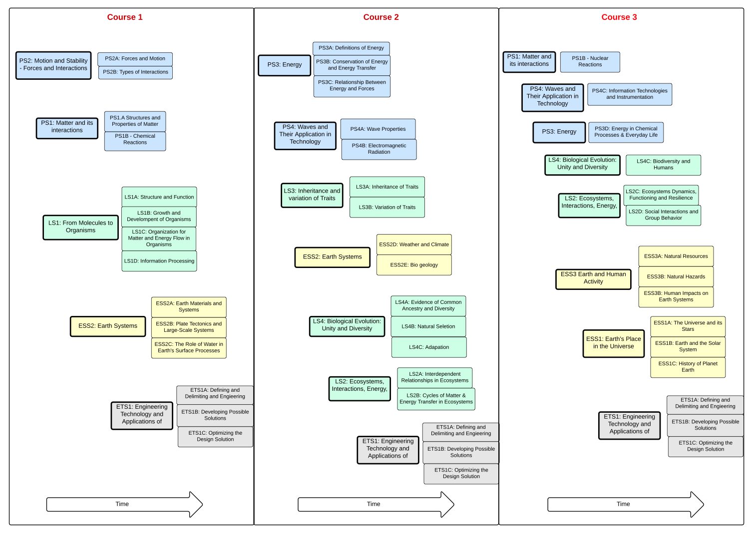
Figure App 4.3: Connection Between the DCIs in the First Year of the Three-Year Model: Every Science, Every Year
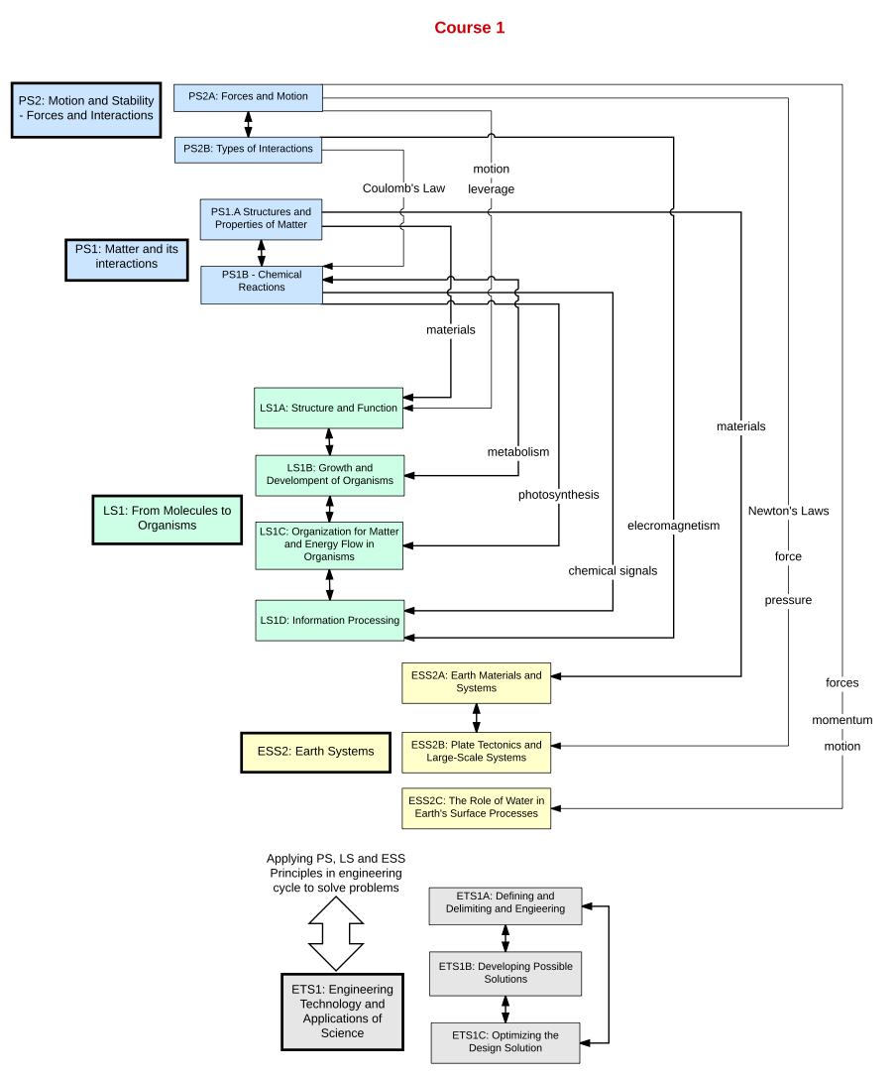
Figure App 4.4: Connection Between the DCIs in the Second Year of the Three-Year Model: Every Science, Every Year
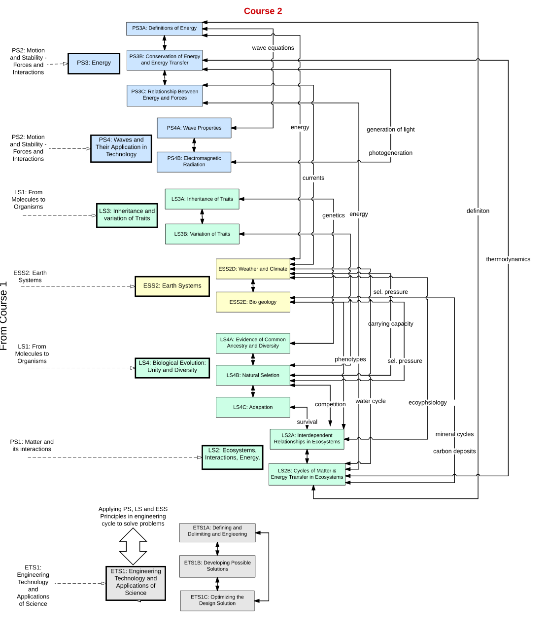
Figure App 4.5: Connection Between the DCIs in the Third Year of the Three-Year Model: Every Science, Every Year

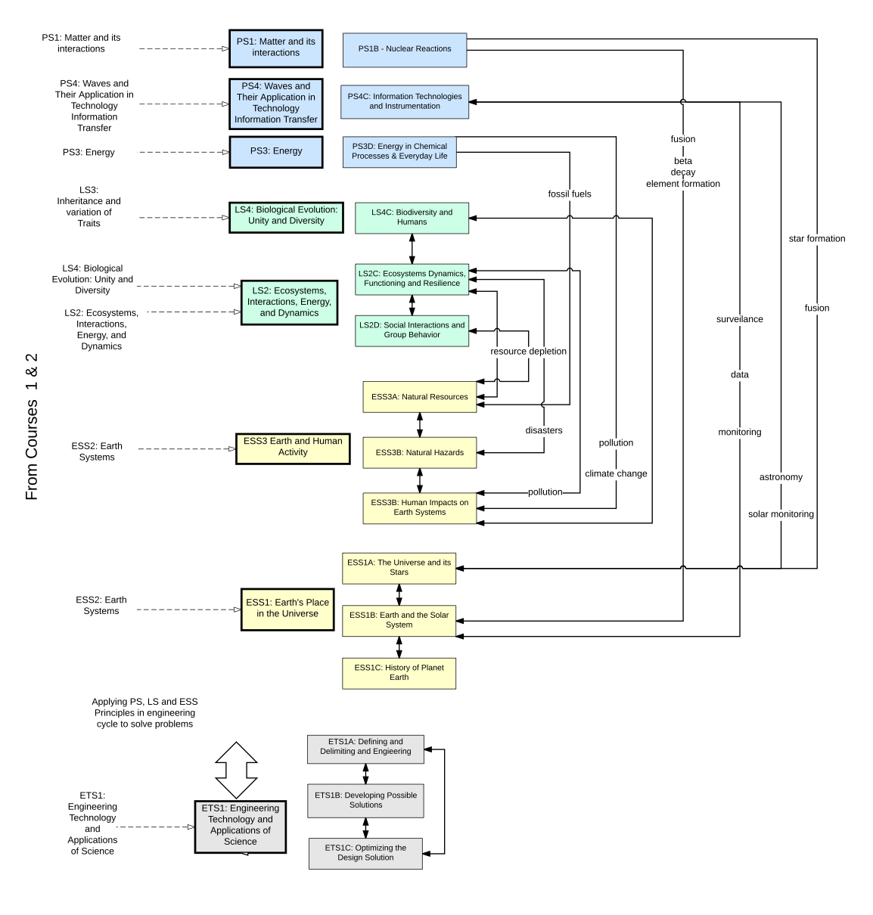
Table App 4.4. Organization of PEs in Sample Three Year Model: Every Science Every Year

DCI | Course 1 |  | Course 2 |  | Course 3
Physical Science | HS-PS1-1  HS-PS1-2  HS-PS1-3  HS-PS1-4  HS-PS1-5  HS-PS1-6  HS-PS1-7 | HS-PS2-1  HS-PS2-2  HS-PS2-3  HS-PS2-4  HS-PS2-5  HS-PS2-6 | HS-PS3-1  HS-PS3-2  HS-PS3-5  HS-PS4-1  HS-PS4-2  HS-PS4-3  HS-PS4-4 |  | HS-PS1-8  HS-PS3-3  HS-PS3-4  HS-PS4-5
Life Science | HS-LS1-1  HS-LS1-2  HS-LS1-3  HS-LS1-4  HS-LS1-5  HS-LS1-6  HS-LS1-7 |  | HS-LS2-1  HS-LS2-2  HS-LS2-3  HS-LS2-4  HS-LS2-5  HS-LS2-6  HS-LS2-7 | HS-LS3-1  HS-LS3-2  HS-LS3-3  HS-LS4-1  HS-LS4-2  HS-LS4-3  HS-LS4-4 | HS-LS2-2  HS-LS2-6  HS-LS2-7  HS-LS2-8  HS-LS4-5  HS-LS4-6
Earth and Space Science | HS-ESS2-1  HS-ESS2-3  HS-ESS2-5 |  | HS-ESS2-2  HS-ESS2-4  HS-ESS2-6  HS-ESS2-7 |  | HS-ESS1-1  HS-ESS1-2  HS-ESS1-3  HS-ESS1-4  HS-ESS1-5  HS-ESS1-6  HS-ESS2-2 | HS-ESS3-1  HS-ESS3-2  HS-ESS3-3  HS-ESS3-4  HS-ESS3-5  HS-ESS3-6
Engineering, Technology, and Society | HS-ETS1-1  HS-ETS1-2  HS-ETS1-3  HS-ETS1-4 |  | HS-ETS1-1  HS-ETS1-2  HS-ETS1-3  HS-ETS1-4 |  | HS-ETS1-1  HS-ETS1-2  HS-ETS1-3  HS-ETS1-4

References

Achieve. 2010. What States Should Know About International Standards in Science: Highlights from Achieve’s Analysis. http://www.achieve.org/files/WHATSTATESHOULDKNOABOUTINTERNATIONALSTANDARDSINSCIENCE.pdf (accessed September 27, 2016).

California Commission on Teacher Credentialing. 2014. Specialized Single Subject Science Credentials and Alignment with the Next Generation Science Standards in California. http://www.ctc.ca.gov/commission/agendas/2014-08/2014-08-4C.pdf (accessed September 27, 2016).

NGSS Lead States. 2013a. Executive Summary. http://www.nextgenscience.org/sites/ngss/files/Final%20Release%20NGSS%20Front%20Matter%20-%206.17.13%20Update_0.pdf (accessed September 27, 2016).

———. 2013b. http://nextgenscience.org/ (accessed October 26, 2016).

